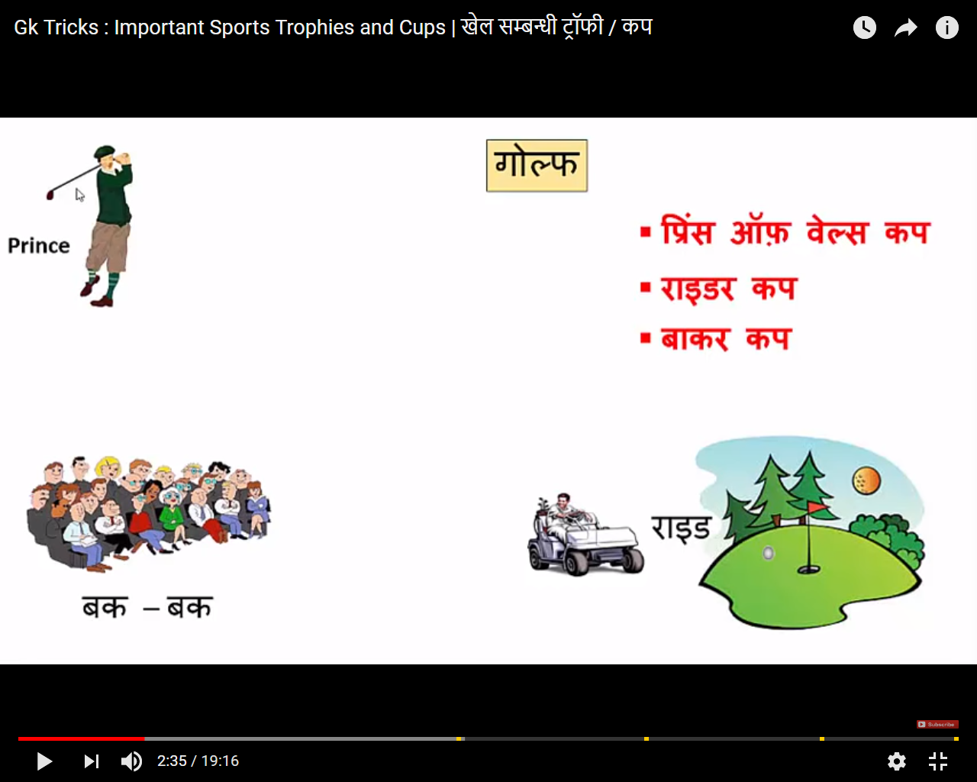

Prince type personality wale golf khelna pasand karte hai.Target tak jane k liye rider jata hai.Audience bor hoti hai aur bak bak karne lagti hai

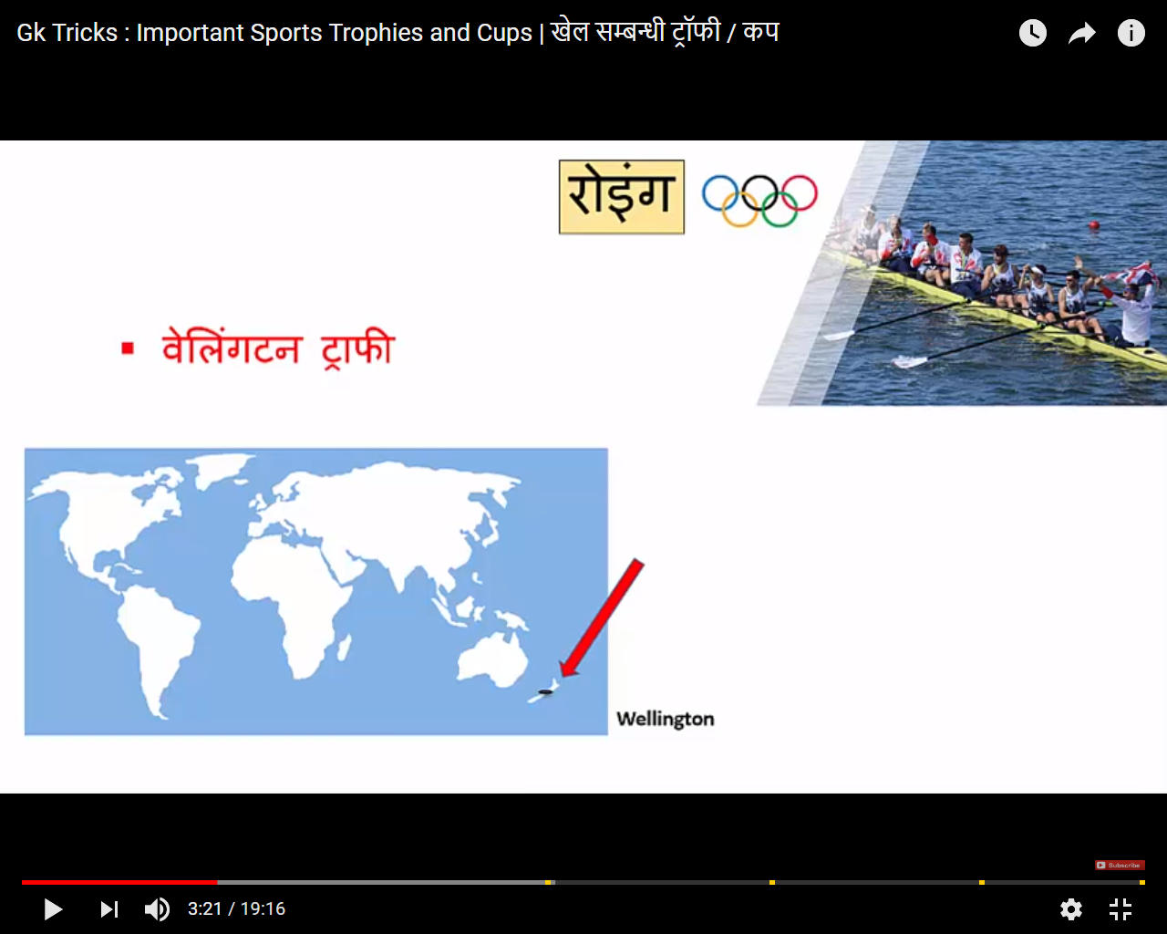

Water charo tariff hai wellington-paani walla khel Roing

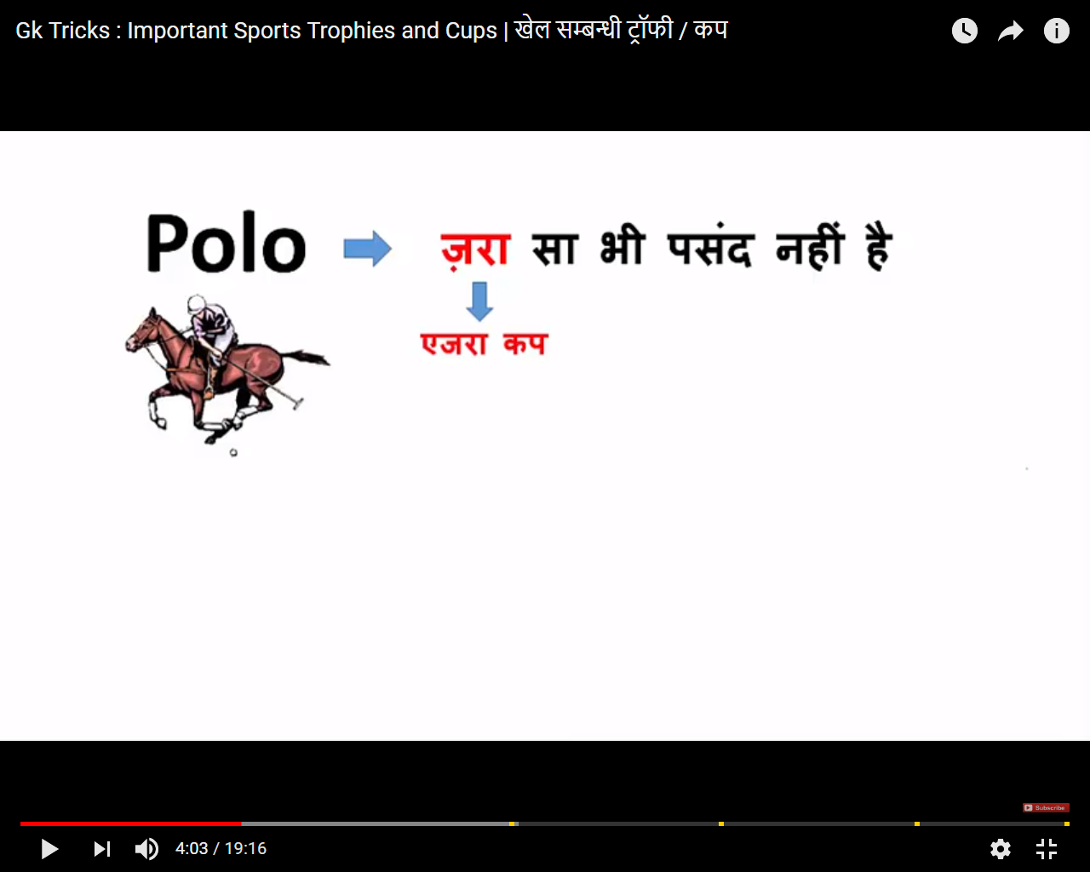

Indian log zara(Aizera) sa bhi nhi game pasand krte hai

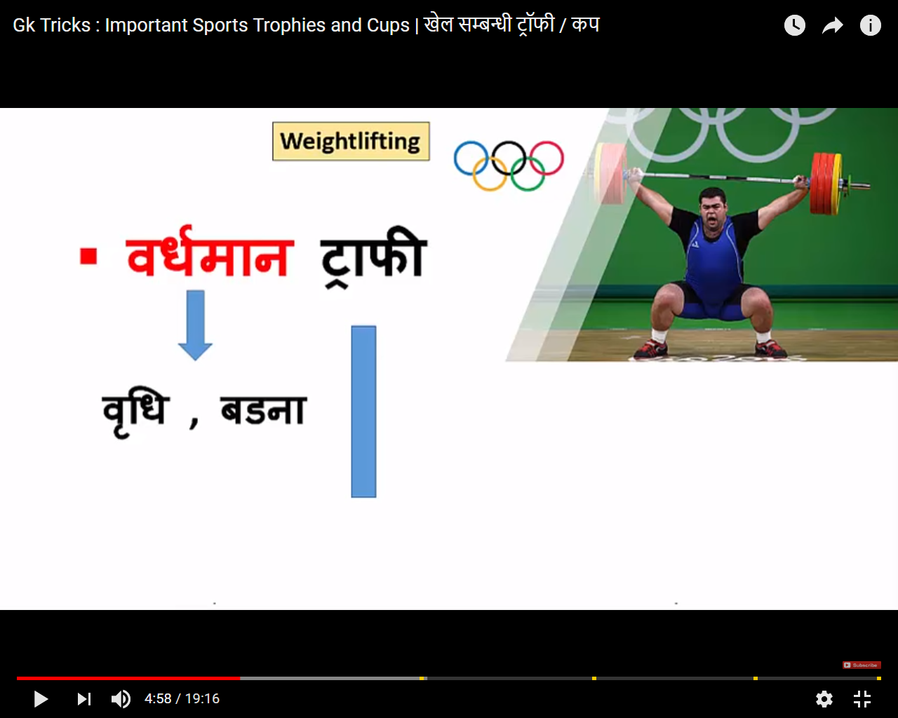

Wight badhan-isme time k sath sath weight badhate hai.

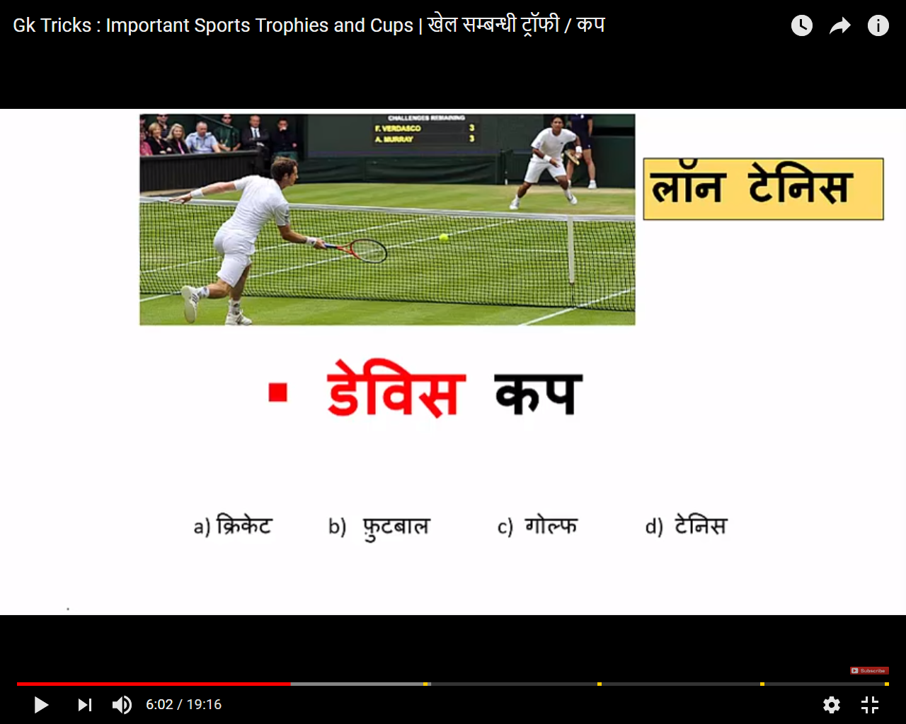

Voice based(dwani based) sound same aa rha hai “Davish-Tannis.

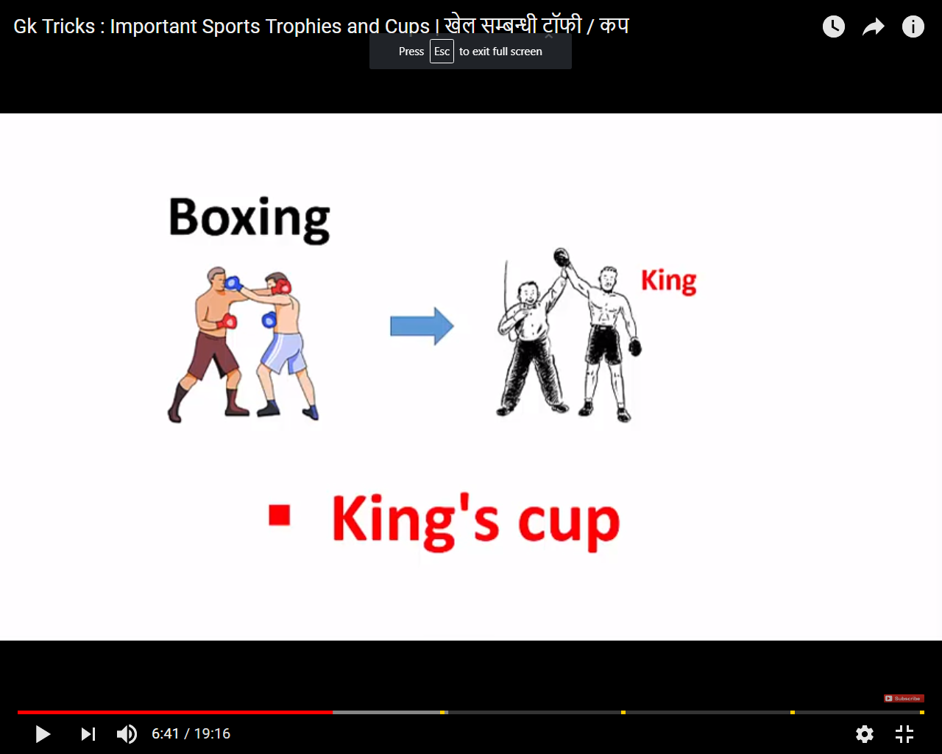

Boxing me jo vijeta hota hai vo King hota hai.

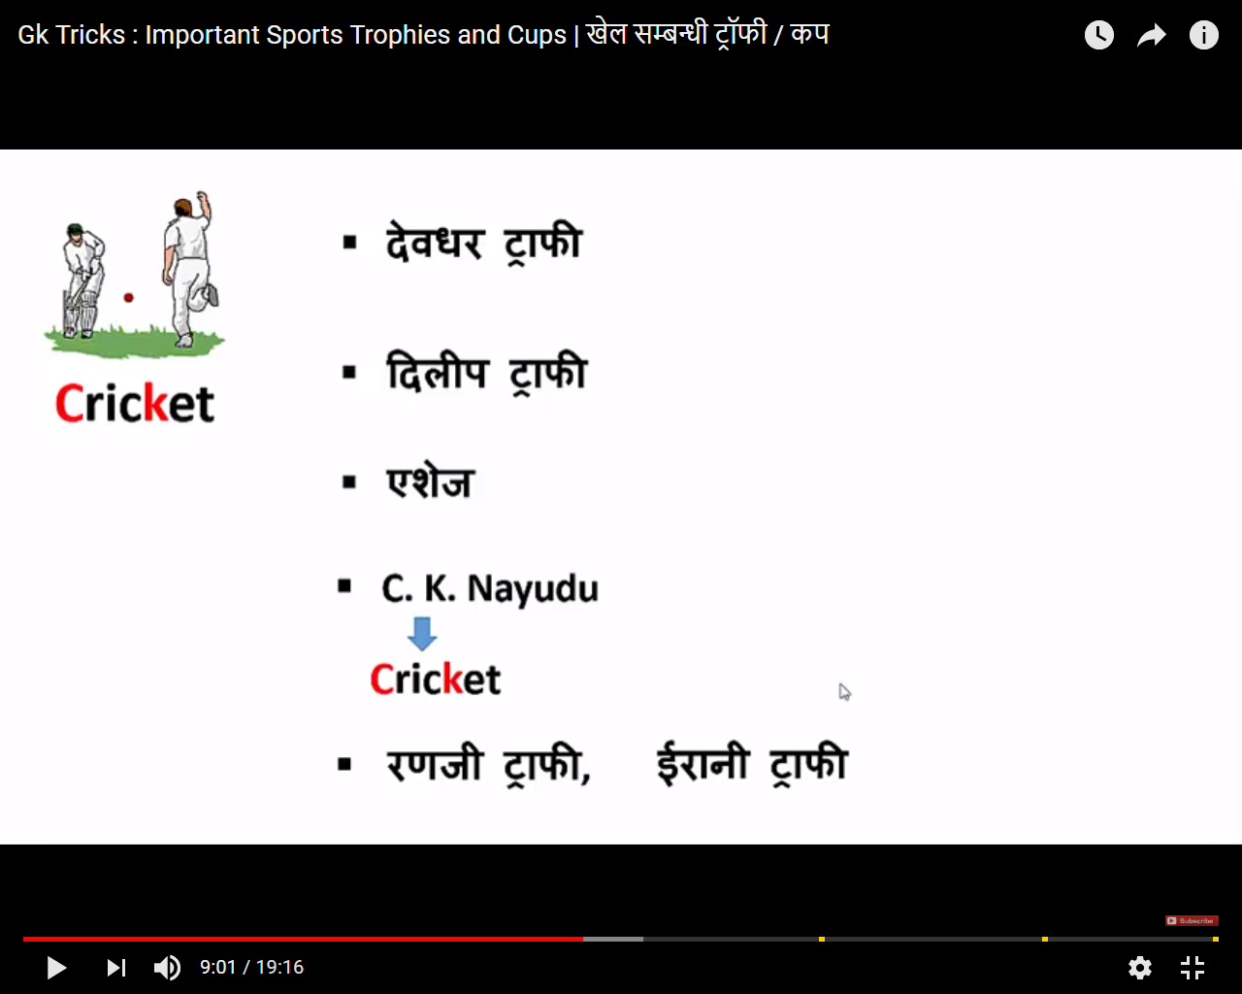

DevDhar->Dev+dhar -> Kapil dev

Dilip Trophy->Dil se connection for indian->Cricket

Aisez-Cricketaro ki life aiso aram wali hoti hai(india australia test series)

CK Nayudu->CK-C se Cricket(india test -> First captain)

Rangi Trophy-Simple

Irani Trophy-Simple

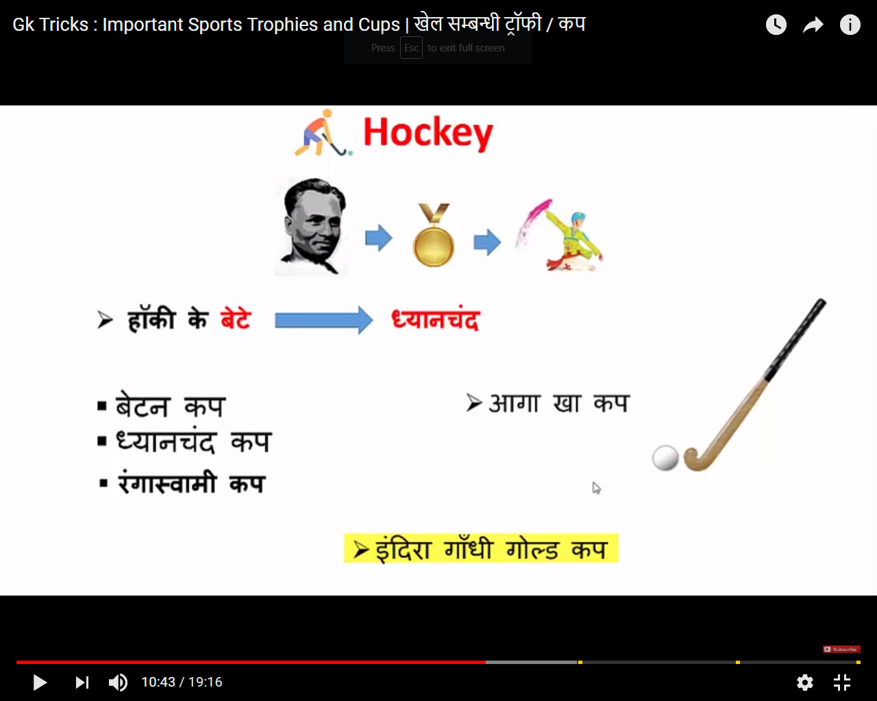

Hockey Kaa Beta ->Betan Cup

JB Maa KA Beta(BetanCup) Dhyanchand trophy jeet k aata tha to rung(Color) udate the.-RangaSwami.

Jb Dhyanchand khelte the to unki Hockey AAG uglti thi-AAGA kha Cup.

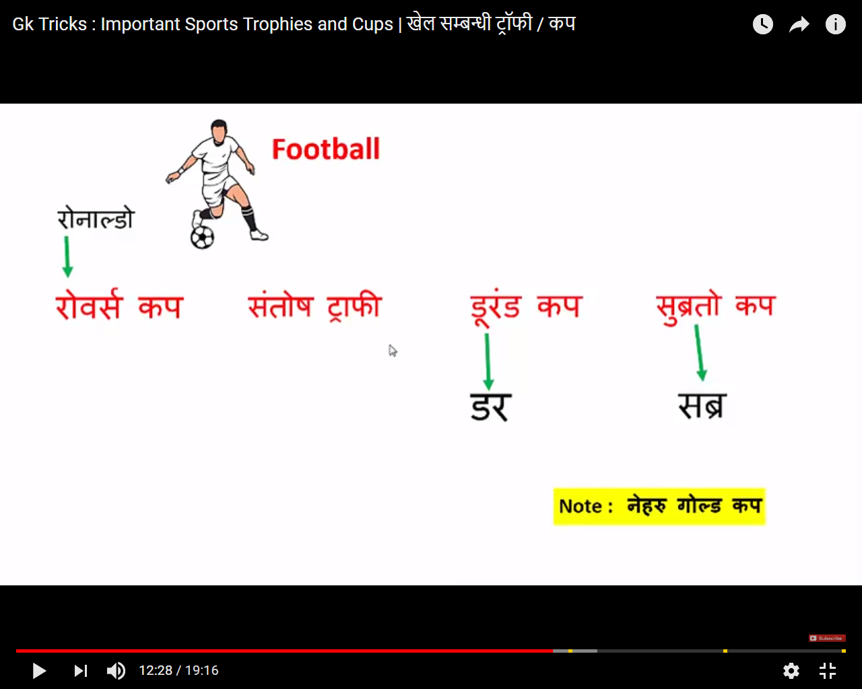

Ronaldo-Ro se Roverse Cup bana->Jb Ronaldo ne Roverse Cup jita to unhe Santosh(Santosh Trophy) mili.

Durand Cup-Dar ka khel matlab-Dhakka mukki wala khel hai to Football khelne se Dar lagta hai.

Subrato Trophy->Sabra kr rahe hai kb indian team trophy jeet k layegi.

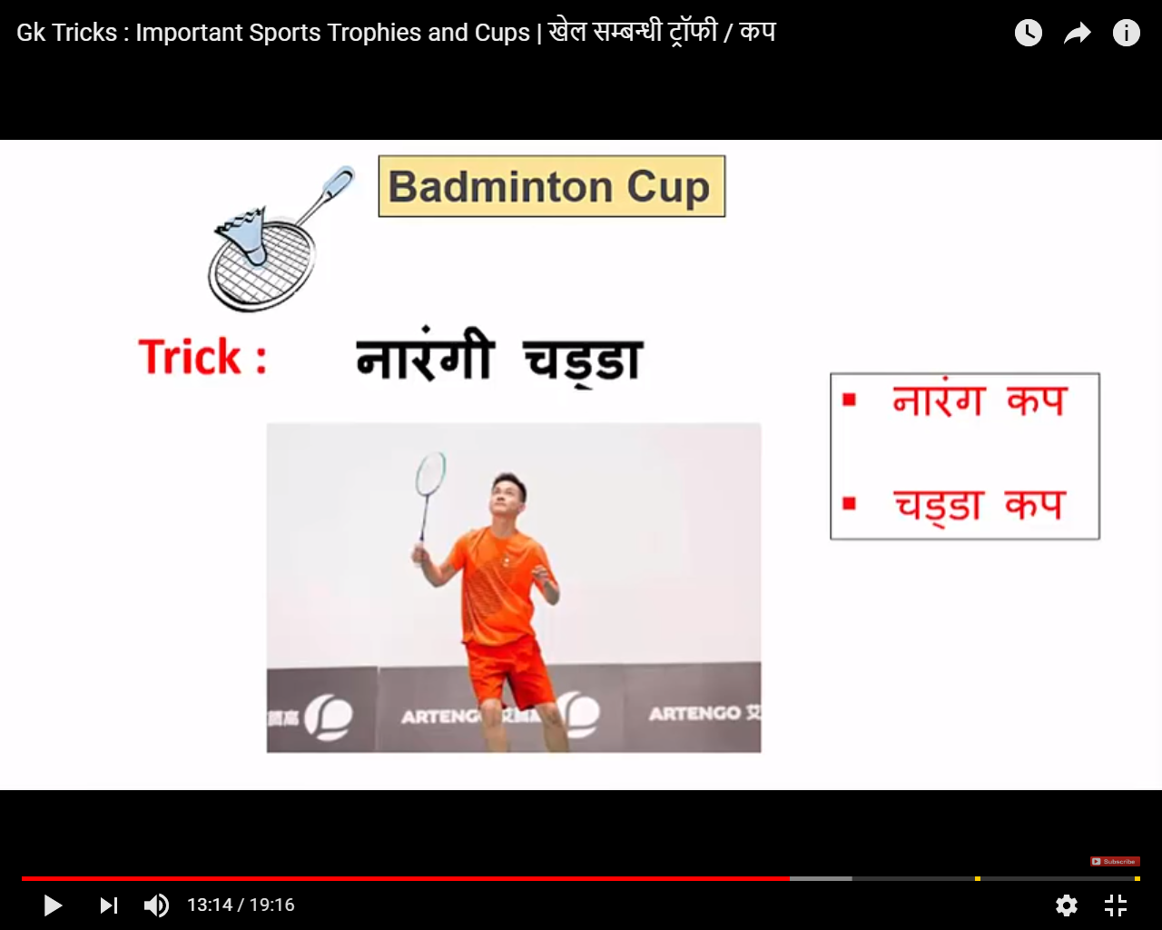

Tricks-Narangi chadda pahen kr kheloge to har match jeet jao ge.

